Please ask for: | Alan Muir
Email: | transportschemes@ somerset.gov.uk
Direct Dial: | 01823 356030
Date: | <Date letter sent>
<Recipient Name>
<1st line of Address>
<2nd line of Address>
<3rd line of Address>
<4th line of Address>
<5th line of Address>

Transport Scheme Commissioning

Dear Resident,

Ref: Your views on possible changes on Neville’s Batch, Guerney Slade

We are writing to seek residents' views on possible changes to the road layout and access along Neville’s Batch.

Somerset Council are exploring locations where removing through routes for motor vehicles could improve access for people walking, cycling and horse riding.

Neville’s Batch has been identified as an opportunity to achieve this by:
- helping to alleviate concerns raised by some residents about traffic cutting through lanes to get to the A37;
- providing a safer route for walking and cycling towards Shepton Mallet and the Strawberry Line to the southwest; the west towards Wookey; and
- helping to create a more attractive route towards Chilcompton also referred to as the aspirational Somerset Circle route via Radstock, Bristol and Cheddar.

If progressed, any changes would be put in as a trial under an Experimental Traffic Order that can last up to 18 months. This would enable residents to try it out, with further consultation to inform any decision on whether the scheme should be made permanent.

A potential location for an initial trial has been identified along Neville’s Batch, approximately 170 metres south of the junction with Station Road as shown in Plans 1 and 2.

People on foot, wheeling or cycling would still be able to travel through the motor vehicle restriction also known as a modal filter. This could be achieved using bollards, planters or concrete blocks with additional signage to make road users aware of the restriction ahead.

We would therefore like to seek your views on the following:
- What do you think of a proposed trial to reduce through traffic on Neville’s Batch?
- Are there any other comments regarding access needs that you would like to raise?

How to Respond
Please get in touch to tell us your views for the questions above by responding via https://somersetcouncil.citizenspace.com/highways/greenlanes or by using the QR code below by Tuesday 24th February 2026.

If you require materials in a different format, please get in touch via email at transportschemes@somerset.gov.uk
Responses can also be sent FAO: Transport Scheme Commissioning as per the address details below.

The Council will also engage with Binegar and Ashwick Parish Councils as part of the consultation. We look forward to hearing your views.


Yours faithfully,

Alan Muir

Principal Transport Planner- Active Travel
Transport Scheme Commissioning
Somerset Council
County Hall
Taunton
TA1 4DY

Plan 1 – Indicative location on Neville’s Batch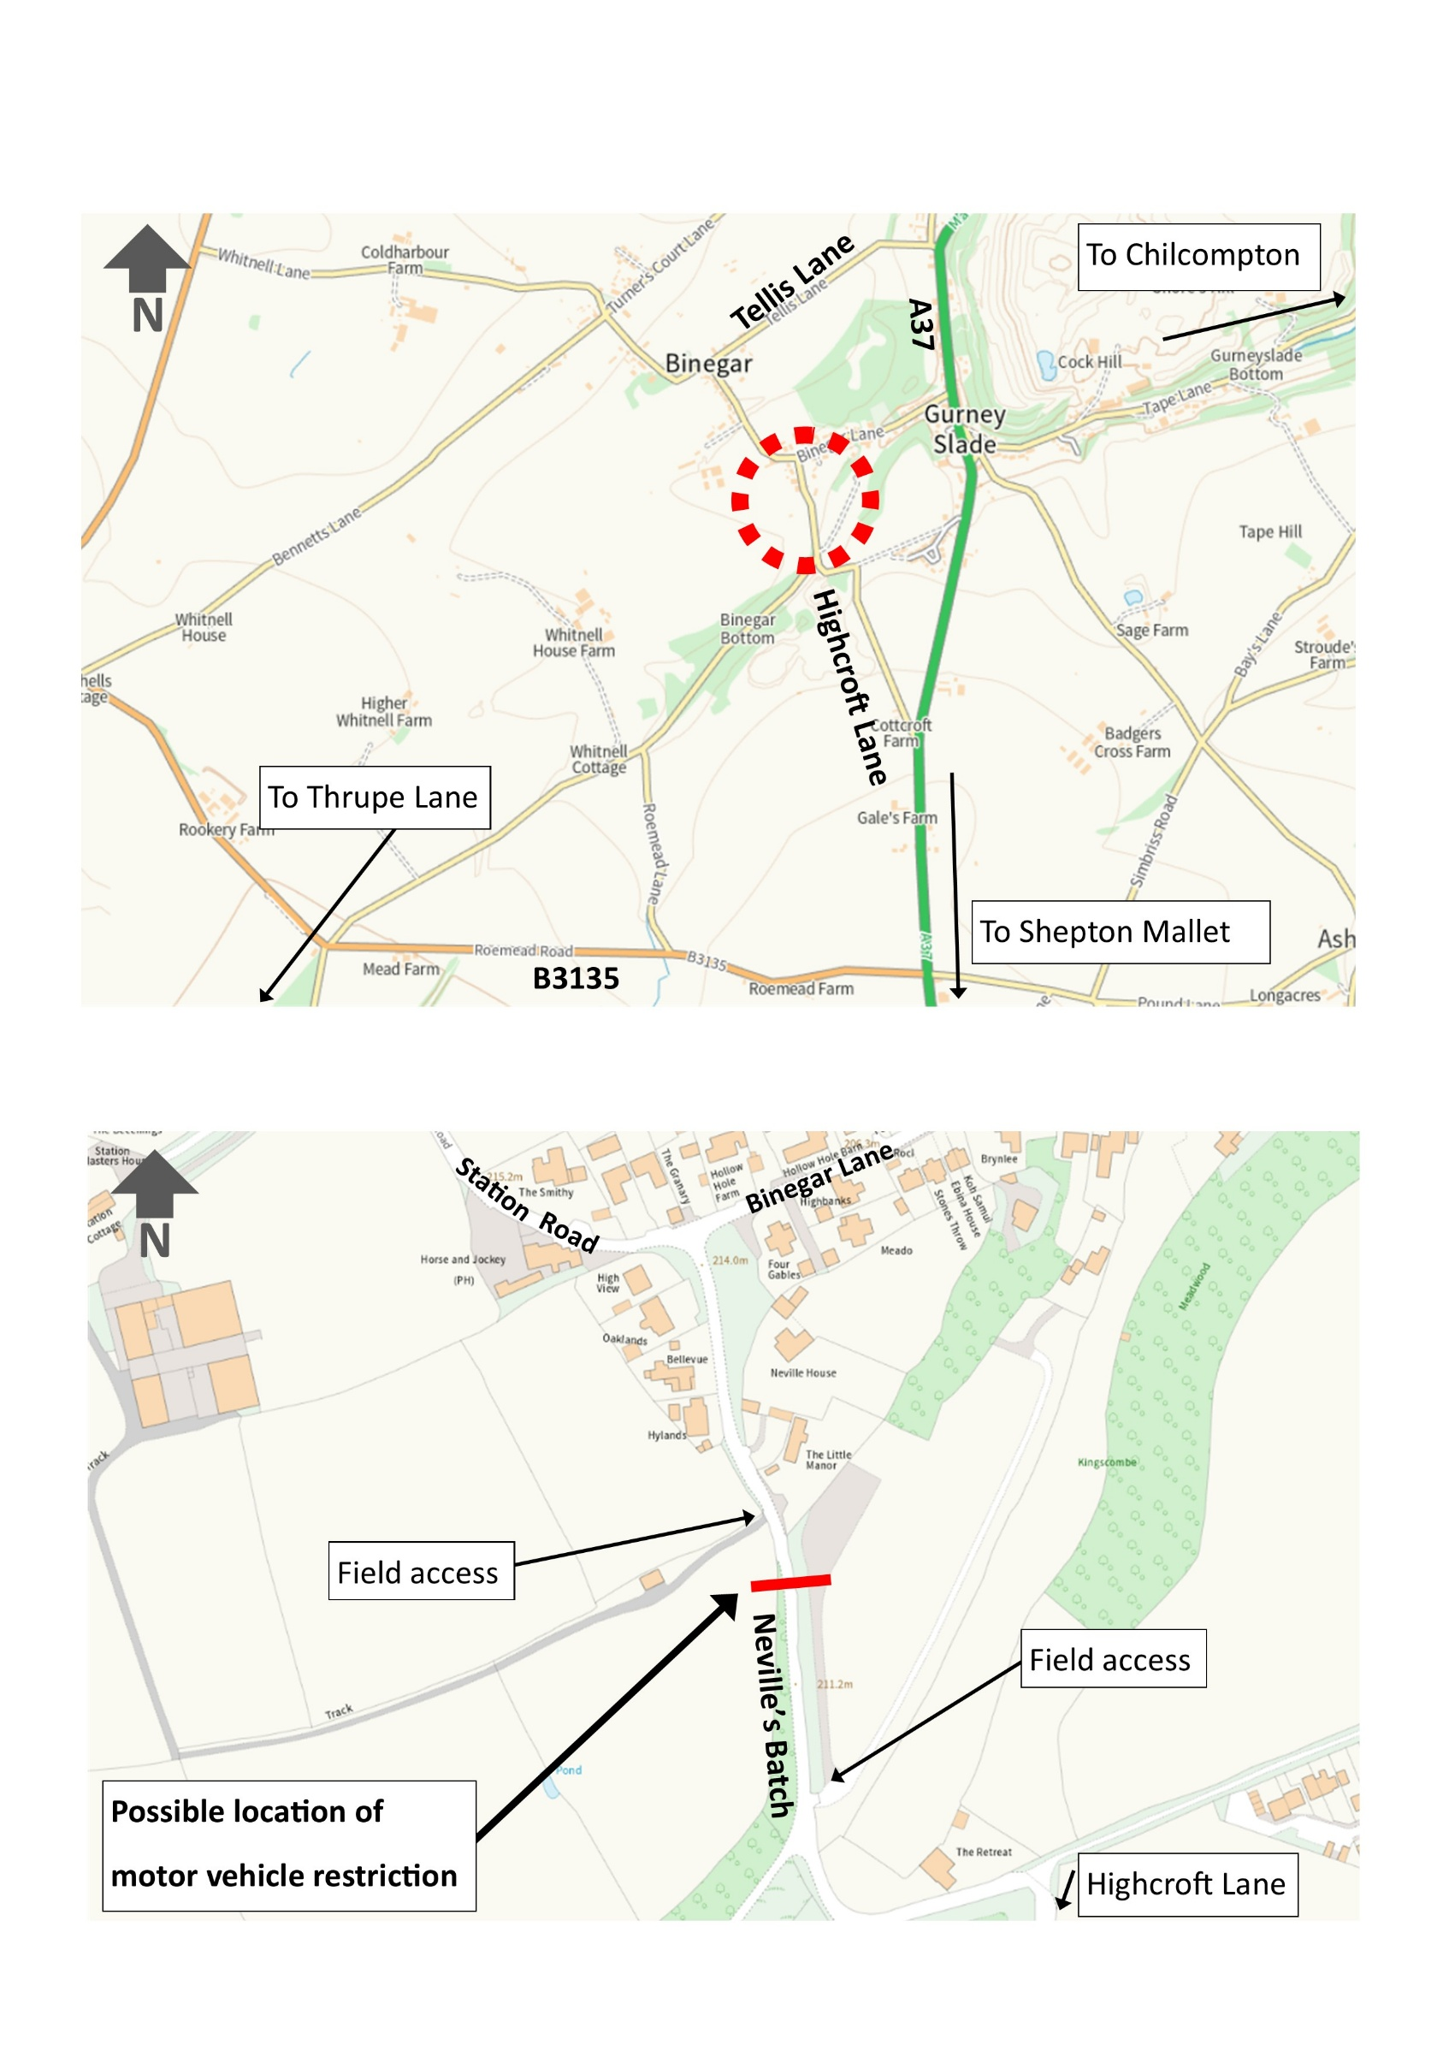
Plan 2 – Indicative location of motor vehicle restriction on Neville’s Batch
Examples of how through traffic could be removed


