Please ask for: | Alan Muir
Email: | transportschemes@ somerset.gov.uk
Direct Dial: | 01823 356030
Date: | <Date letter sent>
<Recipient Name>
<1st line of Address>
<2nd line of Address>
<3rd line of Address>
<4th line of Address>
<5th line of Address>

Transport Scheme Commissioning

Dear Resident,

Ref: Your views on possible changes on Downend Road

We are writing to seek residents' views on possible changes to the road layout and access along Downend Road.

Quiet Lane consultation
Please note that a separate consultation on proposals to create a Quiet Lane between A38/Downend Road to Puriton ended on 9th January. A Quiet Lane is a road that meets specific criteria regarding vehicle speeds and vehicle flows that is designated to highlight that it is used by pedestrians, equestrians and cyclists, as well as motor vehicles. This is achieved through measures such as signage, surfacing and lining. You can find more details here under MN004204 Phase 2 Downend to Puriton: https://www.somerset.gov.uk/roads-travel-and-parking/find-small-improvement-schemes/

Purpose of this consultation
The options below would be considered as additional measures to the Quiet Lane proposals by considering the removal of through routes for motor vehicles. This would be with the view to help improve access for people walking, cycling and horse riding.

Downend Road has been identified as an opportunity to achieve this through:
- supporting measures, to help to create a more attractive route for walking and cycling between Bridgwater and Puriton.

If progressed, any changes would be put in as a trial under an Experimental Traffic Order that can last up to 18 months. This would enable residents to try it out, with further consultation to inform any decision on whether the scheme should be made permanent.

Two potential locations for an initial trial have been identified along Downend Road as shown in Plan 2.

People on foot, wheeling or cycling would still be able to travel through the motor vehicle restriction also known as a modal filter. This could be achieved using bollards, planters or concrete blocks, with additional signage to make road users aware of the restriction ahead.

We would therefore like to seek your views on the following:
- What do you think of a proposed trial to reduce through traffic on Downend Road?
- Which of the two locations on Plan 2 would you prefer for the trial?
- Are there any other comments regarding access needs that you would like to raise?

How to Respond
Please get in touch to tell us your views for the questions above by responding via https://somersetcouncil.citizenspace.com/highways/greenlanes or by using the QR code below by Tuesday 24th February 2026.

If you require materials in a different format, please get in touch via email at transportschemes@somerset.gov.uk
Responses can also be sent FAO: Transport Scheme Commissioning as per the address details below. The Council will also engage with Puriton and Pawlett Parish Councils as part of this consultation. We look forward to hearing your views.

Yours faithfully,

Alan Muir

Principal Transport Planner- Active Travel
Transport Scheme Commissioning
Somerset Council
County Hall
Taunton
TA1 4DY
Plan 1 – Indicative location on Downend Road
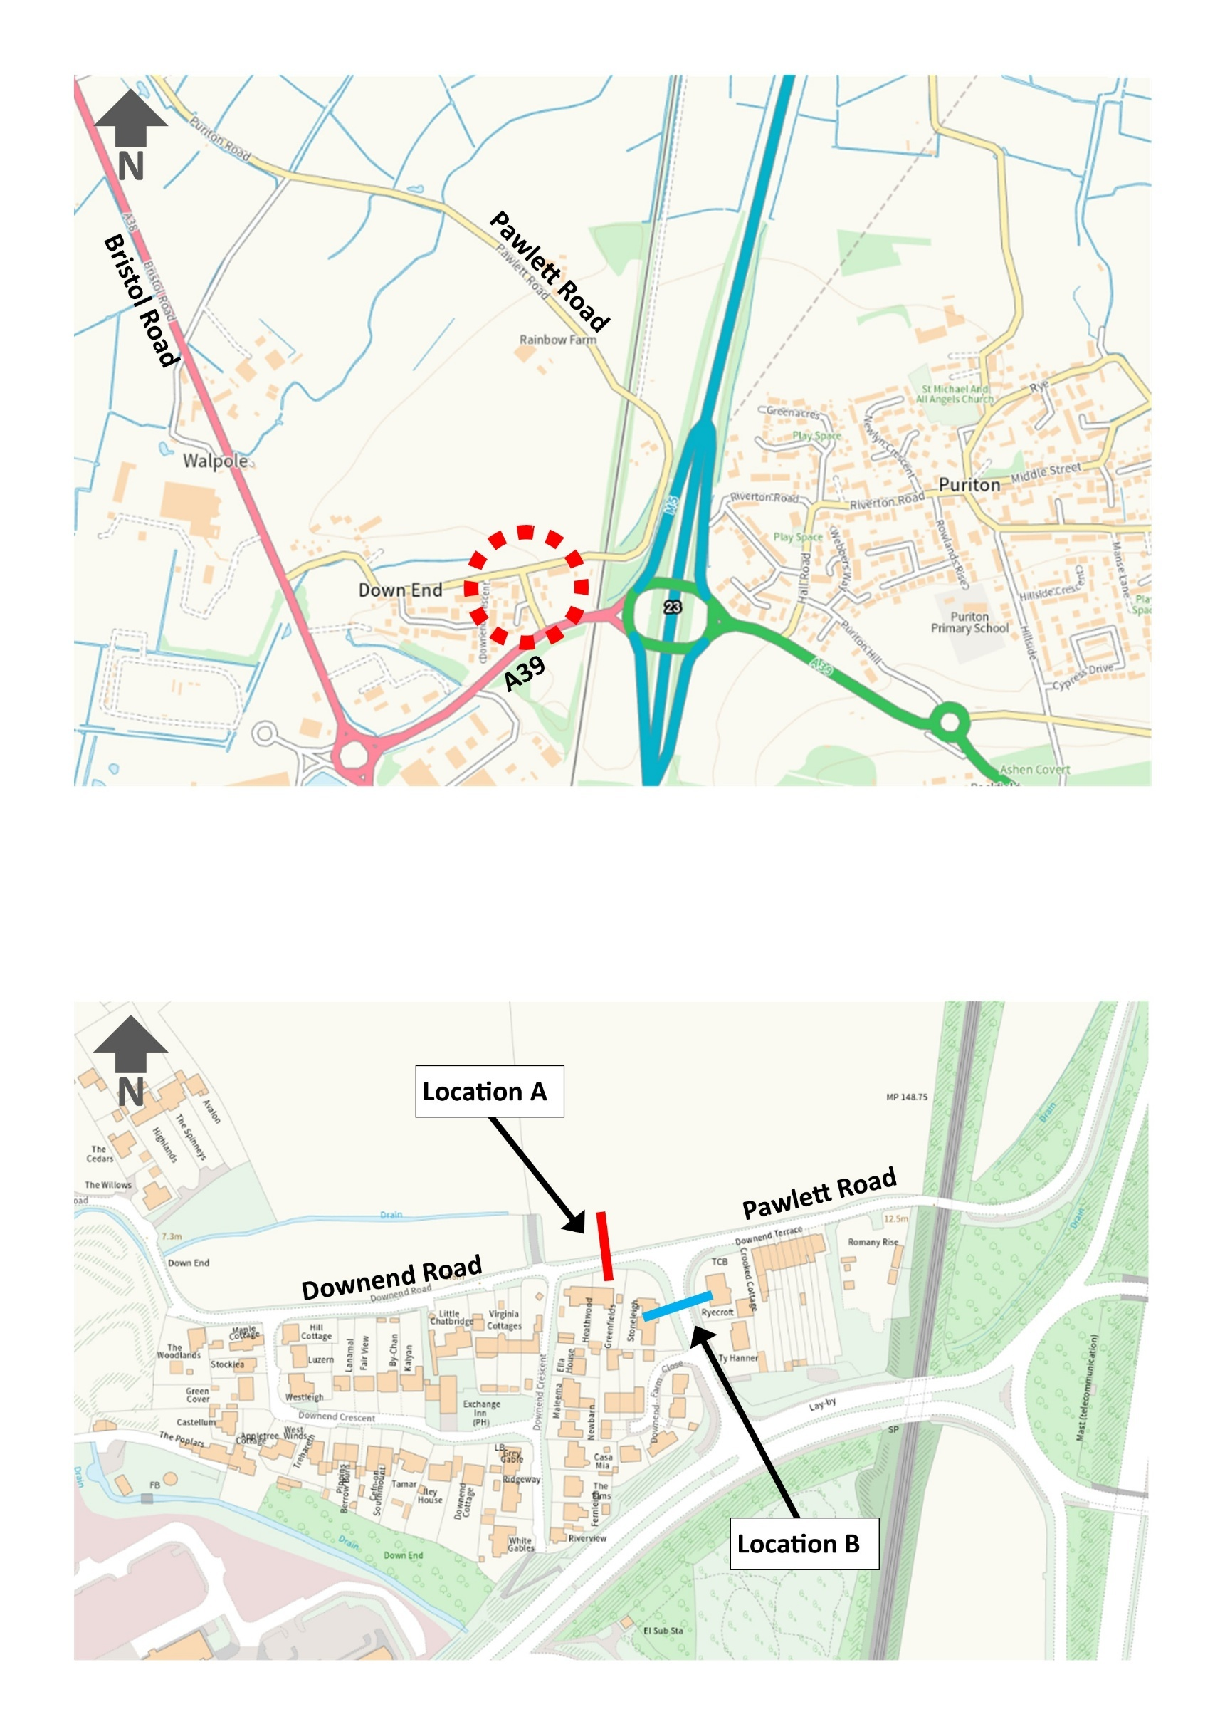

Plan 2 – Indicative locations of motor vehicle restriction on Downend Road
Examples of how through traffic could be removed in either location
