Introduction
Suicide is when somebody intentionally ends their own life. Globally more than 700,000 people die due by suicide every year¹. In 2022, there were 5,642 suicides registered in England and Wales, just over 15 people per day².
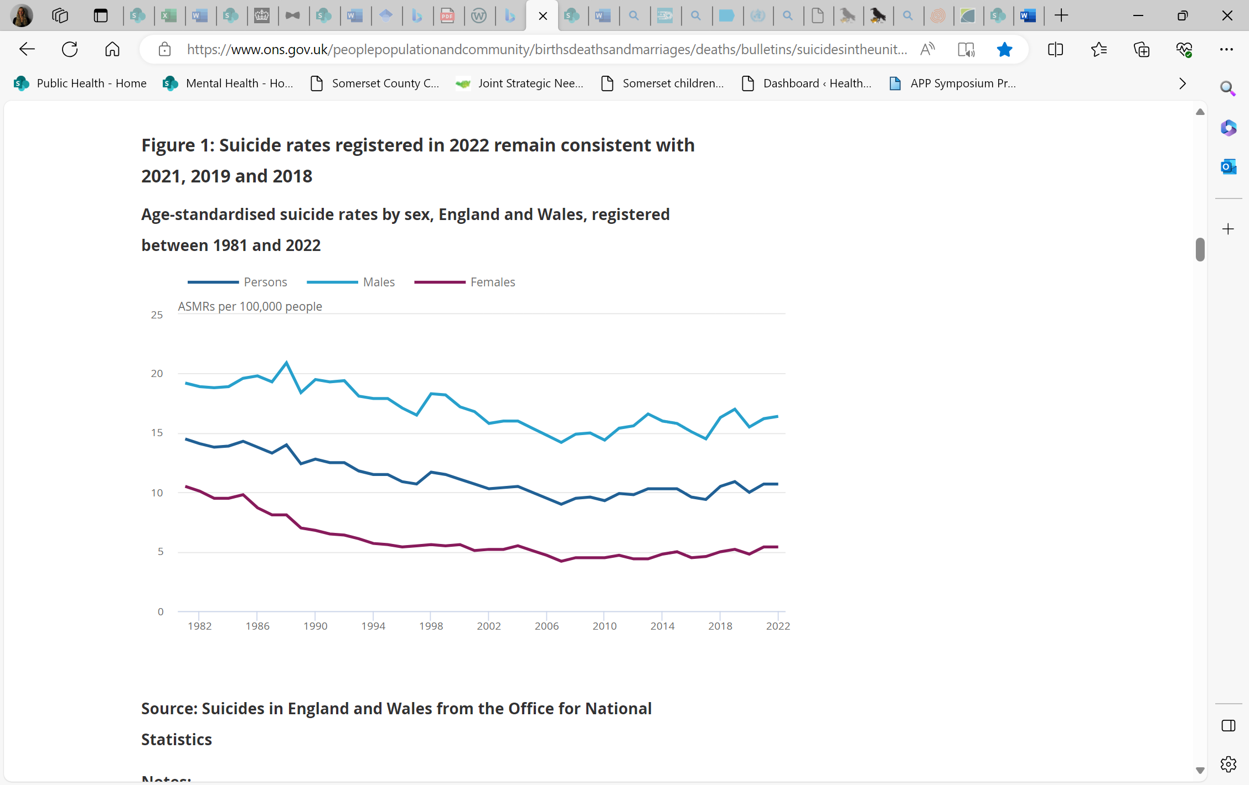
Figure 1: Age-standardised suicide rates by sex, England and Wales, registered between 1981 and 2022 (ONS).
For every suicide there are many more people who attempt suicide. Suicidal thoughts are far more common than many people think, with evidence suggesting that one in five of us will experience suicidal thoughts in our lifetime³.
Having suicidal thoughts does not mean that someone has a mental illness, but there is a connection between mental ill health and suicidal thoughts. It is a common misconception that only those diagnosed with a mental illness are at risk of dying by suicide, however, three quarters of people who died by suicide were not in contact with mental health services in the year leading up to their death⁴.
The circumstances leading to someone taking their own life are often complex and it is rare that one single cause can be identified. There is evidence that links suicide and mental disorders (in particular depression and alcohol use disorders) and a previous suicide attempt however, many suicides happen impulsively in moments of crisis where an individual experiences a lack of resources to deal with biopsychosocial stresses¹.
Every death is a tragedy that has a devastating impact on family, friends, colleagues and whole communities. For every individual that dies by suicide it is estimated that around 135 people will be impacted by that loss, grieving in varying degrees dependent on the closeness of their connection⁵. Support for those impacted by suicide is crucial, as people bereaved by suicide are at an increased risk of mental illness and suicide⁶.
Risk factors
In the UK, the suicide rate is three times higher for males than females, which reflects a global trend. Middle aged men are most at risk⁷. There are various other risk factors associated with suicide and suicide attempts as listed below⁸.
- Gender: males are 3 x more likely to take their own life
- Age: people aged 30-59 are most at risk
- Mental illness
- Treatment and care after suicide attempt
- Previous self-harm
- Previous suicide attempt
- Physical disabilities
- Chronic (long-term) pain
- Alcohol and drug misuse
- Living alone, social exclusion, or isolation
- Bereavement
- Family breakdown and conflict
- Adverse childhood experiences, trauma, abuse and sexual violence
- Identifying as LGBTQ+
- Domestic violence
- Gambling
- Care leavers
- Neurodivergence (Autism, ADHD, Aspergers)
- Deprivation, financial insecurity, unemployment and debt
Risk factors can intersect which can increase an individual’s vulnerability, with stigma, bullying and harassment further exacerbating this.
Suicide Prevention
Suicide is not inevitable and can often be prevented. Just as the circumstances that lead to suicide are complex, the measures to prevent suicide must be equally multifaceted. For this reason, action to prevent suicide is broad and can encompass projects that promote emotional wellbeing, early intervention for mental illness, socioeconomic support, mental health crisis care and support for those bereaved by suicide. Suicide prevention requires a multi-agency approach which engages local and national organisations, communities and individuals.
In 2023 the government released a new cross government suicide prevention strategy, which set out priority areas for action to facilitate collaboration across the system and in communities. The overall ambitions set by this strategy are to: reduce the suicide rate over the next 5 years – with initial reductions observed within half this time or sooner; continue to improve support for people who self-harm; continue to improve support for people who have been bereaved by suicide⁹.
Throughout history there has been stigma associated with mental illness and suicide which still persists today. Stigma stops people from seeking help and can stop people from offering help. Within the national strategy Professor Lois Appleby states that it is crucial that suicide prevention starts with society’s values, breaking down the shame that can deter people from seeking help, fear that can stop people from offering it and with offering young people opportunity and hope.
Understanding local suicide rates
Nationally published suicide rates are based on date of registration. This means that the 2019-21 rates, for example, represent the deaths that were registered in this period and not deaths that occurred in this period.
This includes all deaths from intentional self-harm for persons aged 10 years and over, and deaths caused by injury or poisoning where the intent was undetermined for those aged 15 years and over.
Suicides can be complicated and in almost all cases a coronial inquest will be held. Depending on this and various other factors there can be a number of months between the death occurring and the death actually being registered.
We therefore must be careful when interpreting our suicide rate because the rate will include some deaths that occurred before the period and some deaths that occurred during the period will not be included. To allow for all the registrations to be processed there is also usually a 12-month gap between the period the data was collected and when the data gets published.
When looking at suicide rates locally we use three-year periods rather than annual data. Statistically speaking suicides are relatively rare events and there can also be time specific challenges (for example the impact of the COVID-19 pandemic) in getting deaths registered. By using three-year periods it helps to avoid unfair comparisons based on any years with an unusual registration pattern or where numbers fluctuate due to natural variation.
We also use directly age-standardised rates. This means that any increase in either population size or differences between the age structures of different populations are considered. So when comparing Somerset with England any differences in the rate are not a result of Somerset having an older population: and when looking over time any changes are not a result of the increasing older population.
Somerset data
The rate for suicide in Somerset has generally been slightly higher than the England average over the past twenty years. However, between 2015-17 and 2019-21 the rate in Somerset began to increase year-on-year at a rate much higher than was observed in the national average. This has led to the Somerset rate becoming significantly higher than England for the last 5 periods between 2016-18 and 2019-21.
This shows why suicide is such a priority for Somerset. Despite this, it’s positive to note that Somerset has seen a recent decline in the rate for 2022-24. Based on this period there are currently an average of between 60 and 65 suicides each year in Somerset.
The chart below shows the trends described above. The Somerset value for each period as a coloured circle and the England rate for each year in black. If the Somerset circle is red this means it is significantly higher than the England average.
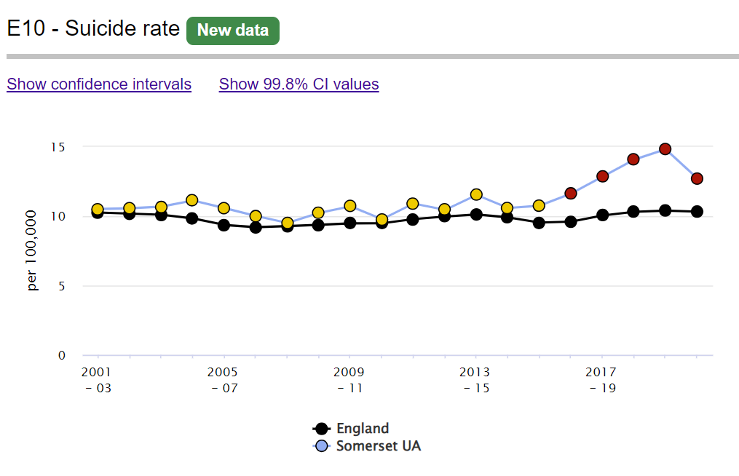
The chart below shows the Somerset rate for Males, Females and all persons. This shows that the recent increase was mostly attributable to an increase in the male rate. However, the female rate also increased and between 2015-17 and 2019-24 and proportionally the rate for females (40%) actually increased by more than that for males (36%).
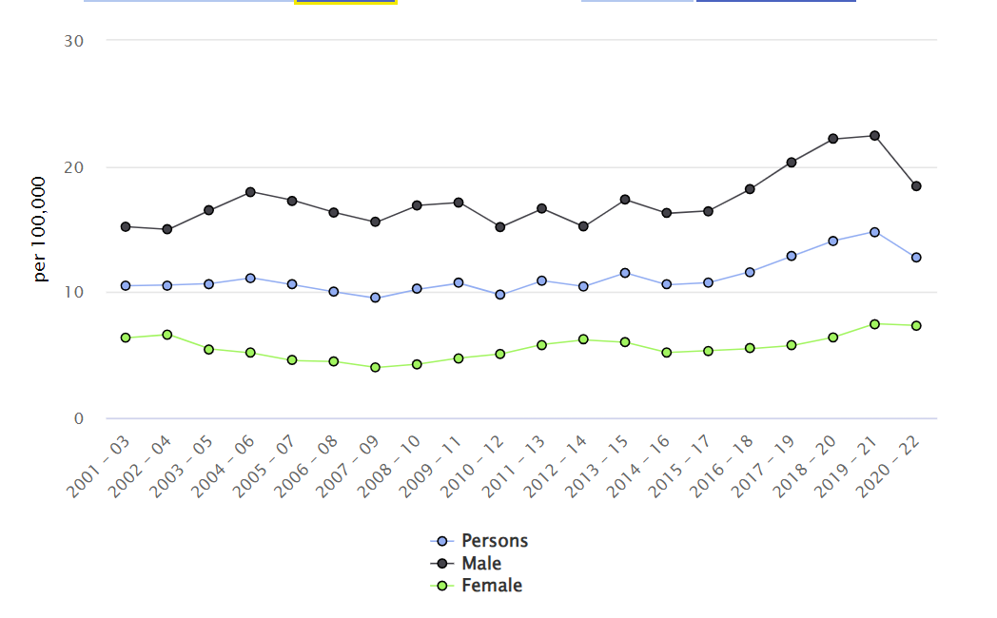

References
1. Suicide (who.int)
2. Suicides in England and Wales - Office for National Statistics (ons.gov.uk)
3. NHS England » Tackling the root causes of suicide
4. display.aspx (manchester.ac.uk)
5. Cerel, J., Brown, M., Maple, M., Singleton, M., van deVenne, J., Moore, M., & Flaherty, C. (2018). How many people are exposed to suicide? Not six. Suicide and Life-Threatening Behavior. DOI: 10.1111/sltb.12450. Retrieved from https://onlinelibrary.wiley.com/doi/pdf/10.1111/sltb.12450
6. Pitman A, Osborn D, King M and Erlangsen A. Effects of suicide bereavement on mental health and suicide risk. The Lancet Psychiatry (2014), vol 1, p86-94. Available from: https://doi.org/10.1016/S2215- 0366(14)70224-X
7. Suicides in England and Wales - Office for National Statistics (ons.gov.uk)
8. NCISH | Annual report 2024: UK patient and general population data 2011-2021 (manchester.ac.uk)
9. Suicide prevention in England: 5-year cross-sector strategy - GOV.UK (www.gov.uk)

Suicides in England and Wales - Office for National Statistics (ons.gov.uk)
Public Health Outcomes Framework - Data - OHID (phe.org.uk)
Public Health Outcomes Framework - Data - OHID (phe.org.uk)

